Uninstall previous version of angular

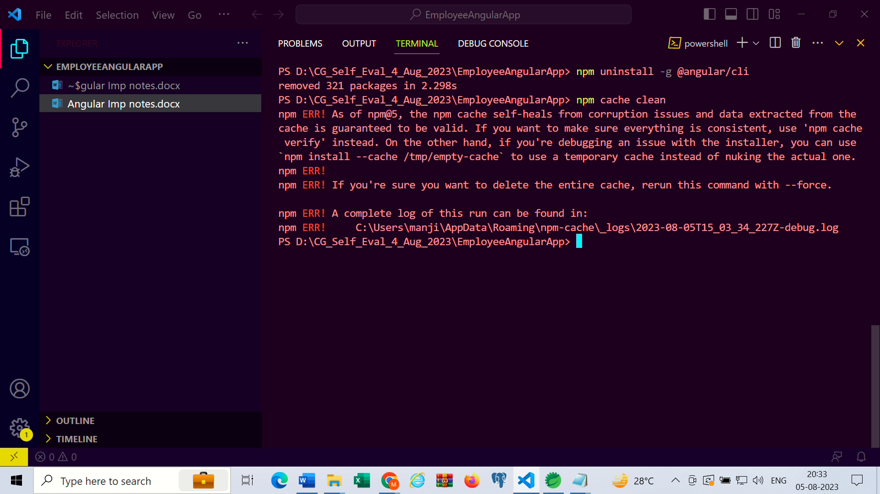

=> npm uninstall -g @angular/cli

=> npm cache clean

To install specific version of angular , do following

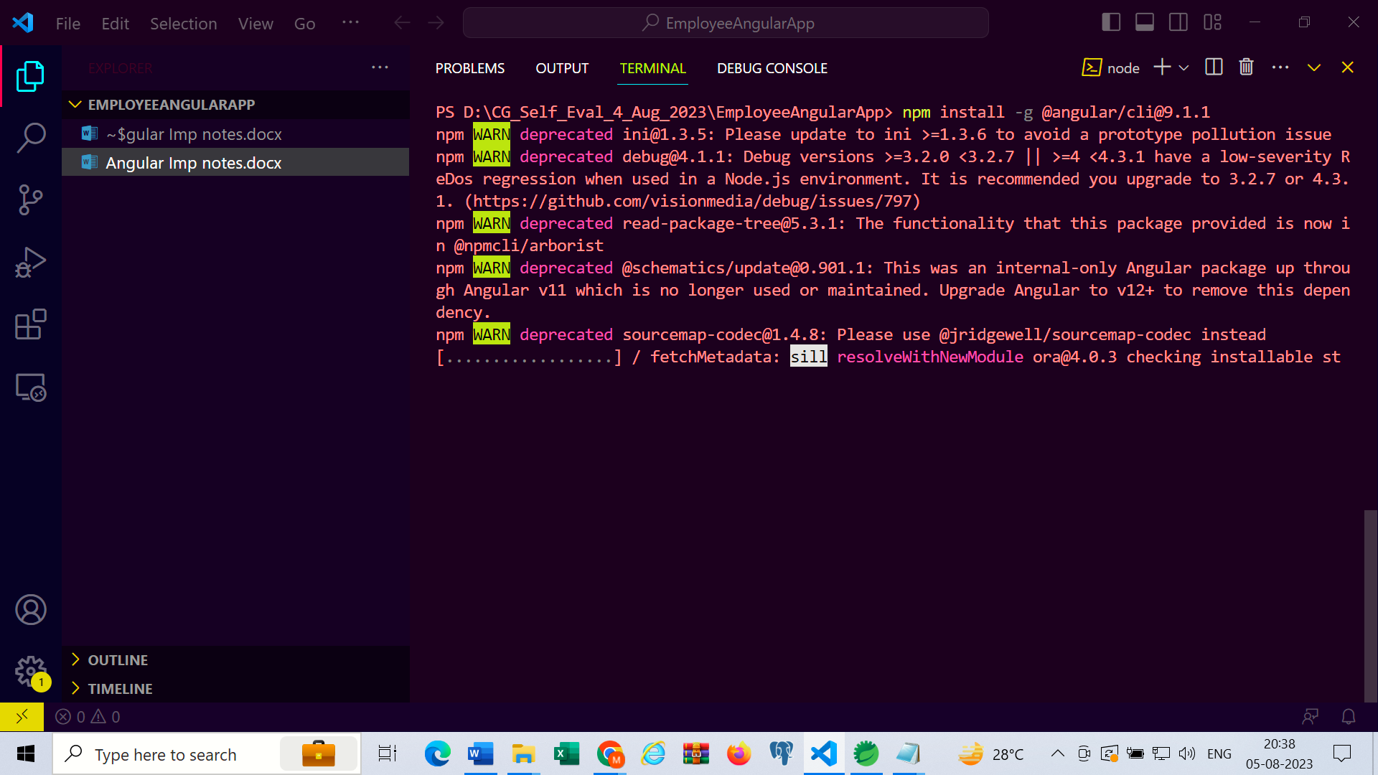

* npm install -g @angular/cli@9.1.1

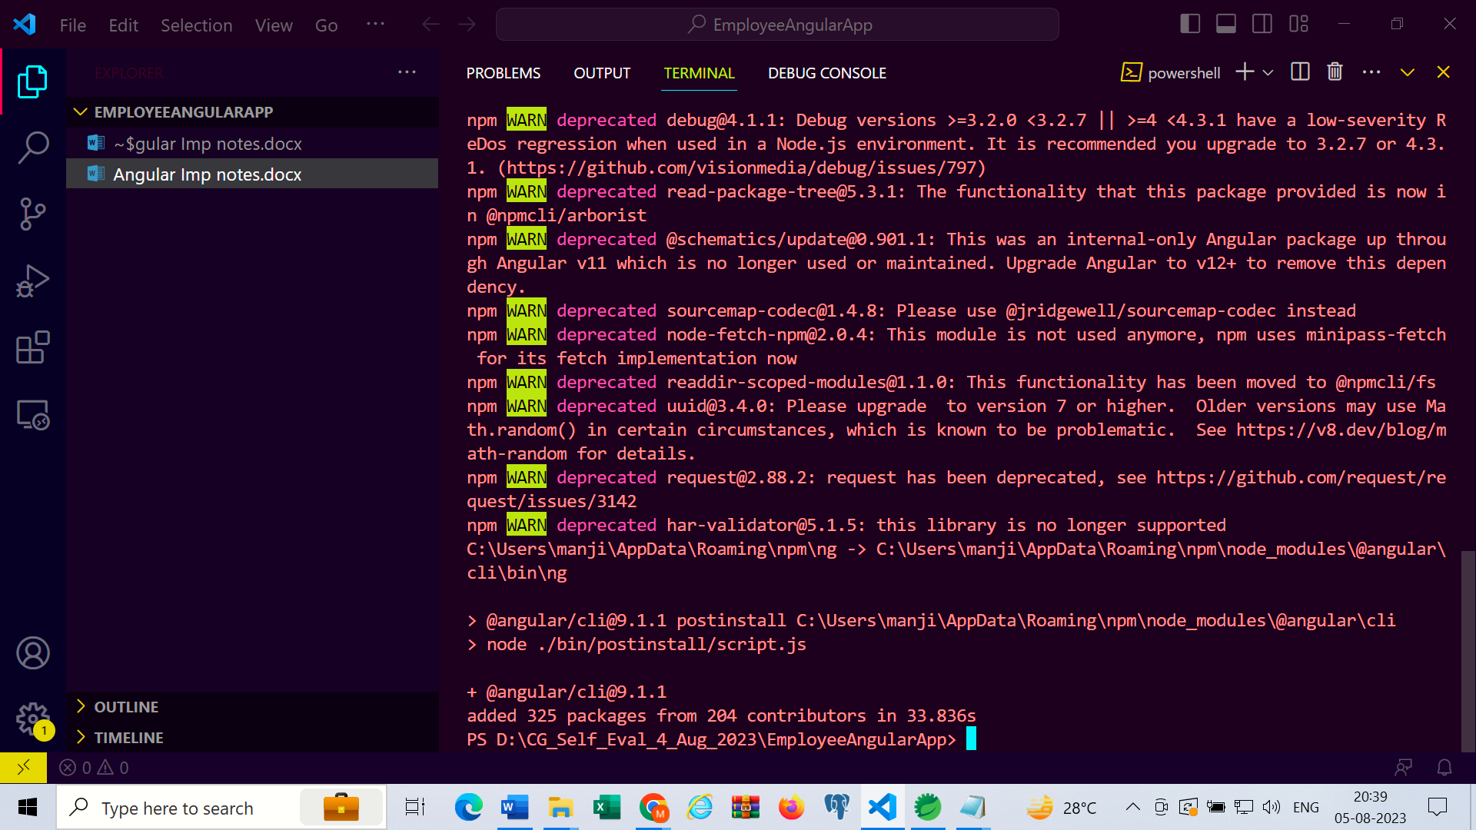

To check angular version

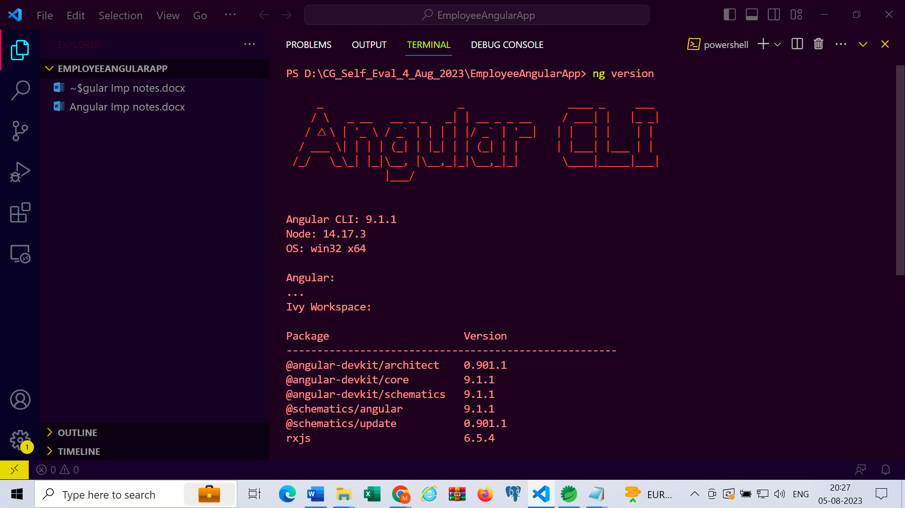

PS D:\CG_Self_Eval_4_Aug_2023\EmployeeAngularApp> ng version

_ _ ____ _ ___

/ \ _ __ __ _ _ _| | __ _ _ __ / ___| | |_ _|

/ △ \ | '_ \ / _` | | | | |/ _` | '__| | | | | | |

/ ___ \| | | | (_| | |_| | | (_| | | | |___| |___ | |

/_/ \_\_| |_|\__, |\__,_|_|\__,_|_| \____|_____|___|

|___/

Angular CLI: 9.1.1

Node: 14.17.3

OS: win32 x64

Angular:

...

Ivy Workspace:

Package Version

------------------------------------------------------

@angular-devkit/architect 0.901.1

@angular-devkit/core 9.1.1

@angular-devkit/schematics 9.1.1

@schematics/angular 9.1.1

@schematics/update 0.901.1

rxjs 6.5.4

Create new web application

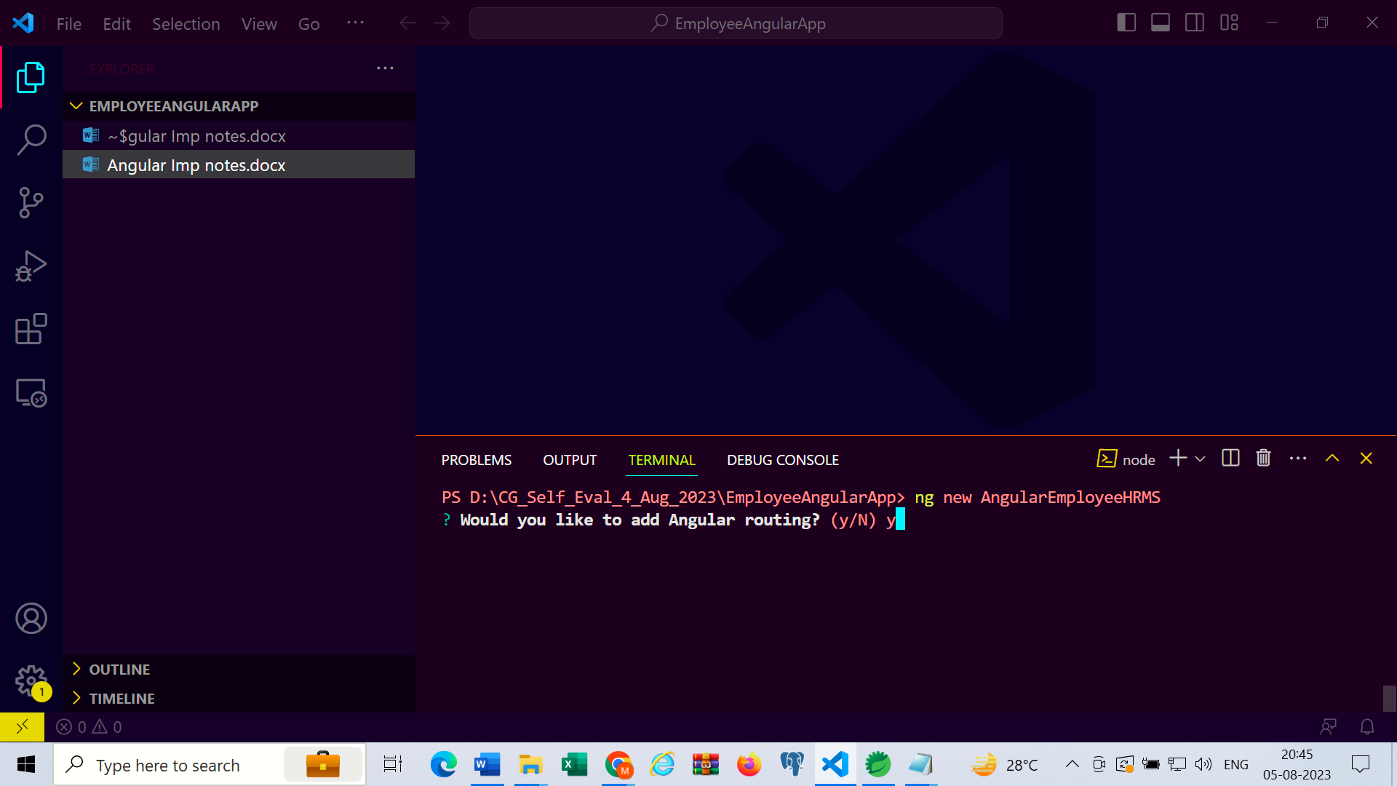

* ng new AngularEmployeeHRMS

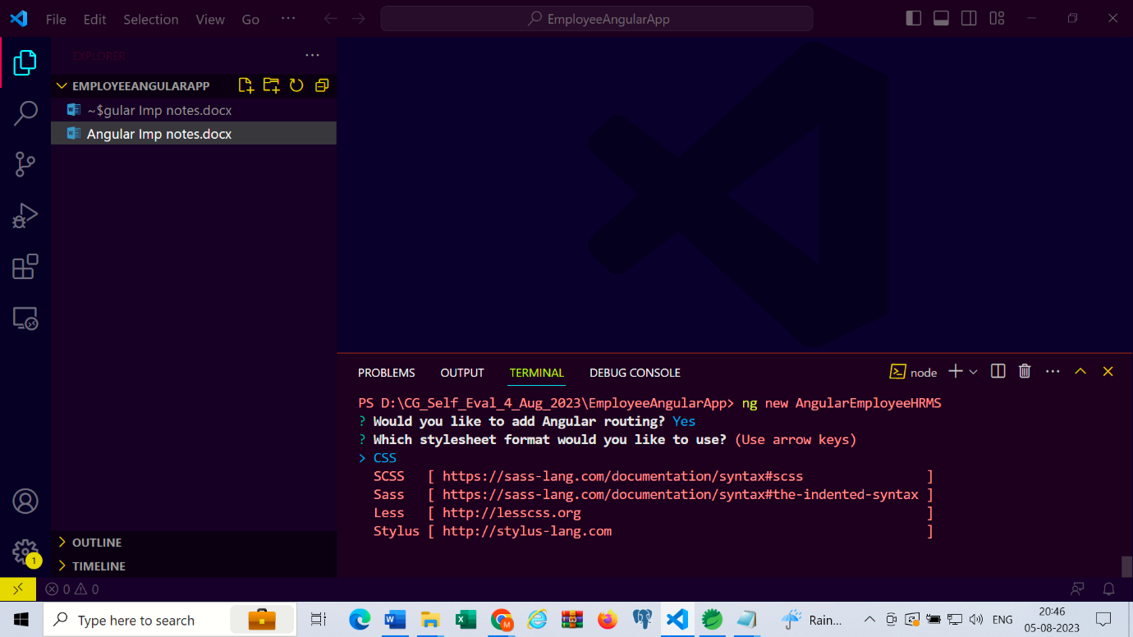

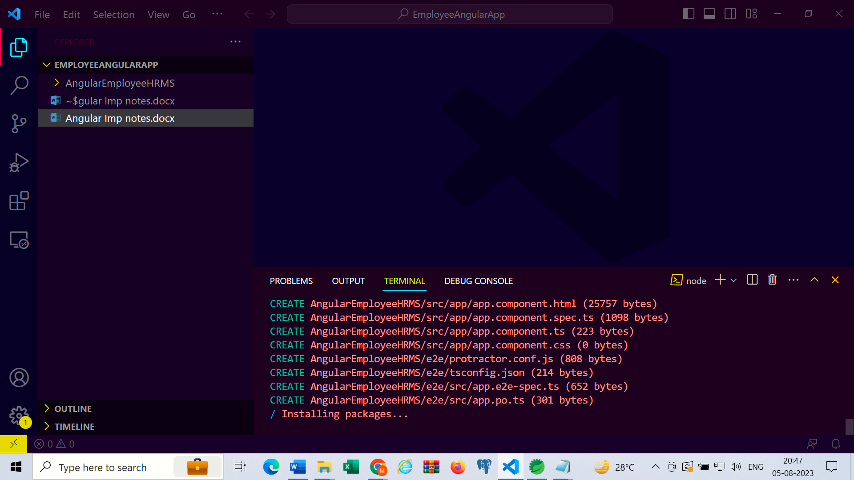

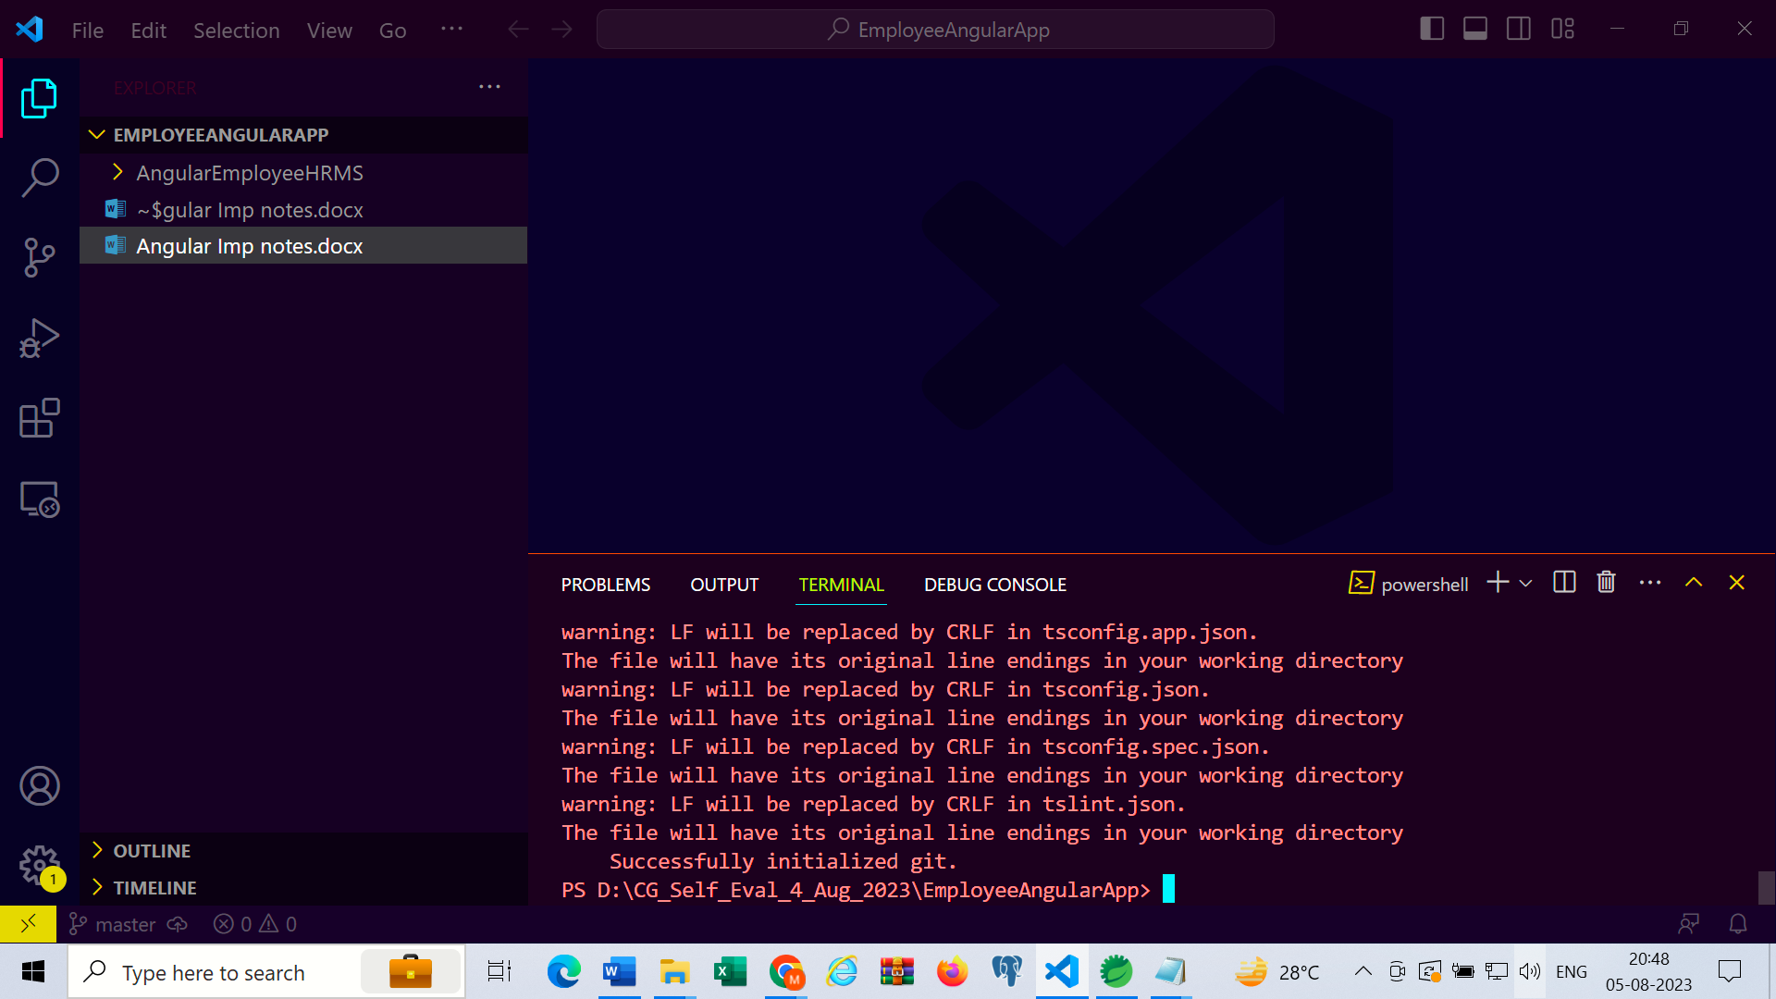

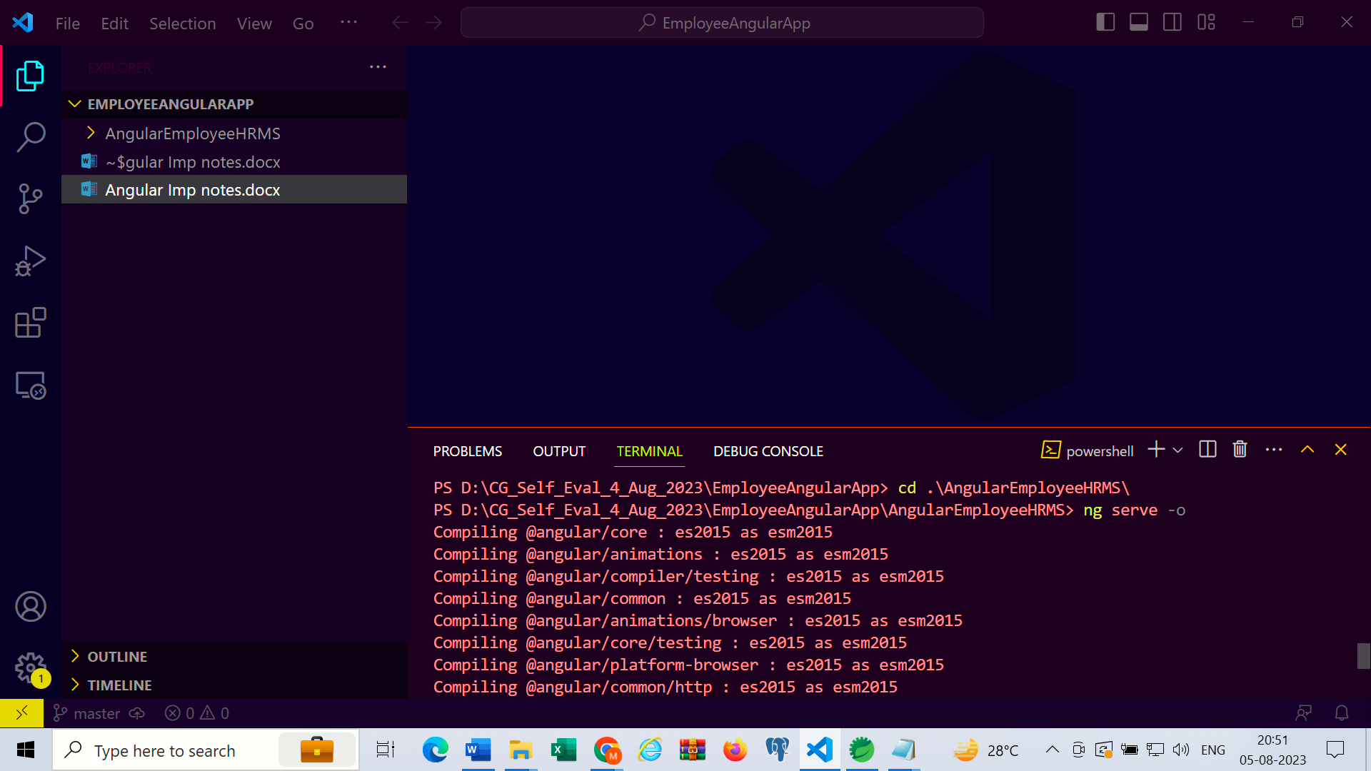

* cd .\AngularEmployeeHRMS\
* ng serve -o

Create components

* ng g c signup
* ng g c login
* ng g c aboutus

Install following for jwt and login and authorization

* npm install --save @auth0/angular-jwt@4.2.0
* npm install --save jwt-decode
* ng g interceptor interceptor/authorization
* ng g service service/user
* ng g guard guard/adminguard
* ng g guard guard/employeeguard
* ng g class model/JwtRequestDTO
* ng g class model/JwtResponseDTO